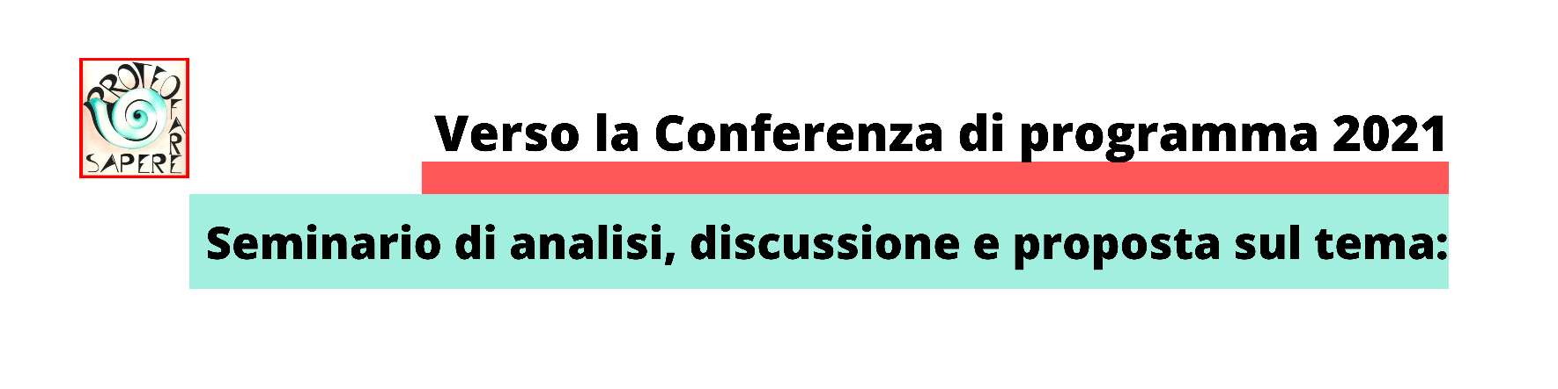

https://transcripts.gotomeeting.com/#/s/8fda422c5ba249ac2836b51364ebe11cdae5835fa19c276555b96cd1ba71d759

